Computer Science & Information Systems

**Big Data Systems – Spark Lab Sheet 2**

**Spark Shell Operations**

1. Objective:

Students should be able to

1. Get familiarity with the Apache Spark system
2. Get hands-on experience with Spark Shell commands

This lab sheet provides a quick introduction to using Spark. This exercise will introduce the API through Spark’s interactive shell (in Python), then next labs will show how to write applications in Python.

Note that, before Spark 2.0, the main programming interface of Spark was the Resilient Distributed Dataset (RDD). After Spark 2.0, RDDs are replaced by Dataset, which is strongly-typed like an RDD, but with richer optimizations under the hood. The RDD interface is still supported, and one can get a more detailed reference at the RDD programming guide. It is highly recommend to switch to use Dataset, which has better performance than RDD, but as RDDs are basic blocks of Spark, we will be getting familiarity with them in this lab sheet.

At a high level, every Spark application consists of a driver program that runs the user’s main function and executes various parallel operations on a cluster. The main abstraction Spark provides is a resilient distributed dataset (RDD), which is a collection of elements partitioned across the nodes of the cluster that can be operated on in parallel. RDDs are created by starting with a file in the Hadoop file system (or any other Hadoop-supported file system), or an existing Scala collection in the driver program, and transforming it. Users may also ask Spark to persist an RDD in memory, allowing it to be reused efficiently across parallel operations. Finally, RDDs automatically recover from node failures.

1. Steps to be performed:

Note - It’s assumed that student has made a slot reservation using the slot booking interface where Apache Spark framework was selected. The details of the Apache Spark systems to be used is received through an email. If not, please contact the administrators for the same.

Also it’s assumed that students are aware of the process of logging into these virtual machines. If not, then get access to the user manual maintained for the usage of remote lab setup.

**Data Preparations -**

1. Open the terminal by right clicking on the desktop of the virtual machine.

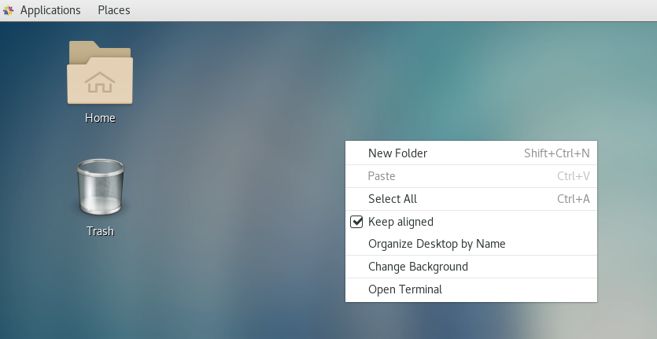

1. Look at the current directory and also file listings in it. It must have a spark installation directory present in it. Commands like pwd, ls can be used for it.

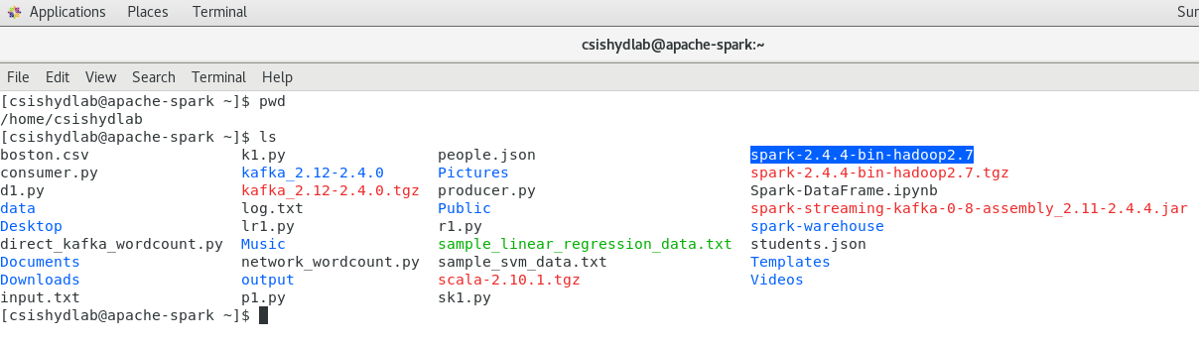

1. Set the SPARK_HOME and HOME variable to point to the spark installations.

[csishydlab@apache-spark bin]$ pwd

/home/csishydlab/spark-2.4.4-bin-hadoop2.7/bin

[csishydlab@apache-spark bin]$ export SPARK_HOME=/home/csishydlab/spark-2.4.4-bin-hadoop2.7/bin

[csishydlab@apache-spark bin]$ export PATH="$SPARK_HOME/bin:$PATH"

echo $SPARK_HOME

echo $PATH

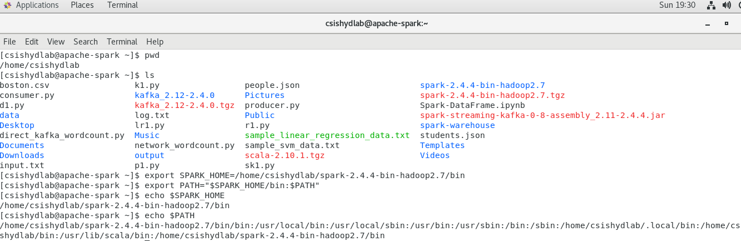

1. Prepare the input text file using any file editor. Copy and paste the content present in the attached input.txt file in this file.

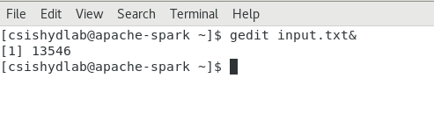

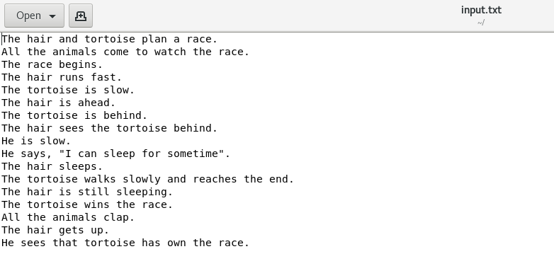

**Using the Shell**

1. Login using the sudo privileges.

sudo su

Enter the root password. Note that the prompt will change now.

1. Enter the Spark shell using the ‘pyspark’ .

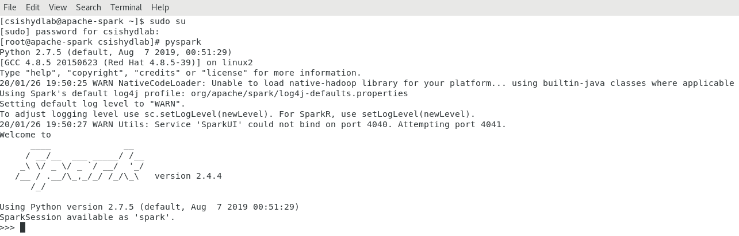

In the PySpark shell, a special interpreter-aware SparkContext is already created, in the variable called sc. Making your own SparkContext will not work. You can set which master the context connects to using the --master argument, and you can add Python .zip, .egg or .py files to the runtime path by passing a comma-separated list to --py-files. You can also add dependencies (e.g. Spark Packages) to your shell session by supplying a comma-separated list of Maven coordinates to the --packages argument. Any additional repositories where dependencies might exist (e.g. Sonatype) can be passed to the --repositories argument. Any Python dependencies a Spark package has (listed in the requirements.txt of that package) must be manually installed using pip when necessary.

**Using the Resilient Distributed Datasets (RDDs)**

Spark revolves around the concept of a resilient distributed dataset (RDD), which is a fault-tolerant collection of elements that can be operated on in parallel. There are two ways to create RDDs: parallelizing an existing collection in your driver program, or referencing a dataset in an external storage system, such as a shared filesystem, HDFS, HBase, or any data source offering a Hadoop InputFormat.

1. Parallelized Collections

Parallelized collections are created by calling SparkContext’s parallelize method on an existing iterable or collection in your driver program. The elements of the collection are copied to form a distributed dataset that can be operated on in parallel. For example, here is how to create a parallelized collection holding the numbers 1 to 5:

>>>data = [1, 2, 3, 4, 5]

>>>distData = sc.parallelize(data)

Once created, the distributed dataset (distData) can be operated on in parallel. For example, we can call distData.reduce(lambda a, b: a + b) to add up the elements of the list.

>>>distData.reduce(lambda a, b: a + b)

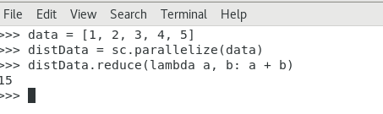

1. Using External Datasets

PySpark can create distributed datasets from any storage source supported by Hadoop, including your local file system, HDFS, Cassandra, HBase, Amazon S3, etc. Spark supports text files, SequenceFiles, and any other Hadoop InputFormat.

Text file RDDs can be created using SparkContext’s textFile method. This method takes an URI for the file (either a local path on the machine, or a hdfs://, s3a://, etc URI) and reads it as a collection of lines. Here is an example invocation:

>>> lines = sc.textFile("input.txt")

Once created, distFile can be acted on by dataset operations.

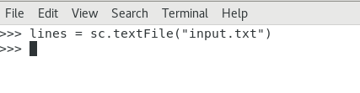

1. Several operations can be performed on the text RDDs as follows

>>>lines.count()

Provides the count of lines present in RDD

>>>lines.take(5)

Read the first 5 items of RDD

>>>lines.first()

read the first item of RDD

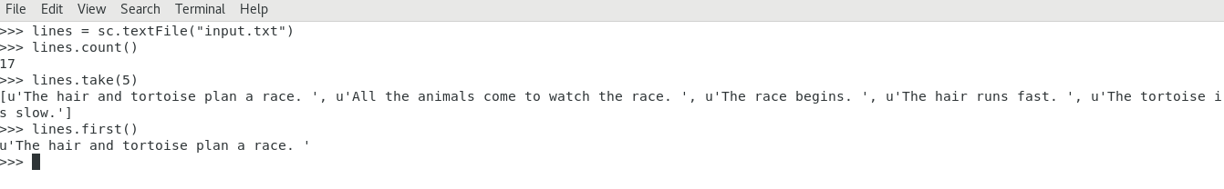

1. We can extract the lines containing the exact words as follows

>>>hairLines = lines.filter(lambda line: "hair" in line)

>>> hairLines.count()

>>> hairLines.first()

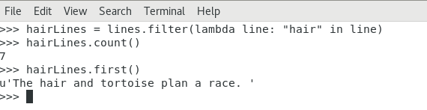

1. One can iterate over the each item in the RDD as follows

>>> for line in hairLines.take(7):\

... print(line)

...

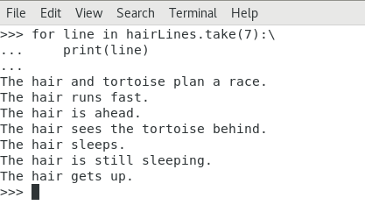

l) Performing RDD Operations

RDDs support two types of operations: transformations, which create a new dataset from an existing one, and actions, which return a value to the driver program after running a computation on the dataset. For example, map is a transformation that passes each dataset element through a function and returns a new RDD representing the results. On the other hand, reduce is an action that aggregates all the elements of the RDD using some function and returns the final result to the driver program (although there is also a parallel reduceByKey that returns a distributed dataset).

All transformations in Spark are lazy, in that they do not compute their results right away. Instead, they just remember the transformations applied to some base dataset (e.g. a file). The transformations are only computed when an action requires a result to be returned to the driver program. This design enables Spark to run more efficiently. For example, we can realize that a dataset created through map will be used in a reduce and return only the result of the reduce to the driver, rather than the larger mapped dataset.

By default, each transformed RDD may be recomputed each time you run an action on it. However, you may also persist an RDD in memory using the persist (or cache) method, in which case Spark will keep the elements around on the cluster for much faster access the next time you query it. There is also support for persisting RDDs on disk, or replicated across multiple nodes.

Just see how the following code counts the characters present in the all lines of given input file.

>>> lines = sc.textFile("input.txt")

>>> lineLengths = lines.map(lambda s: len(s))

>>> lineLengths

>>> totalLength = lineLengths.reduce(lambda a, b: a + b)

>>> totalLength

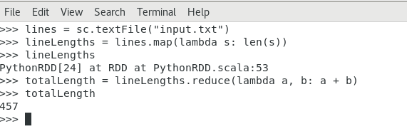

1. Let’s try out a simple word count programme using the RDDs

>>>words = lines.flatMap(lambda line: line.split(" "))

>>>words.count()

>>>words.take(5)

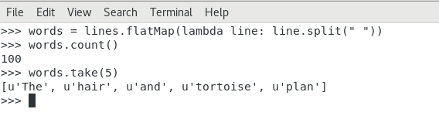

1. Exit the shell using the exit() command.

>>>exit()

1. Outputs/Results:

* Students should be able to see the usage of spark shell for the RDD creations and transformations.

1. Observations:

* Students carefully needs to observe the syntax the python commands used for RDD creation, transformations.

1. References:
2. [Spark Documentation](https://spark.apache.org/docs/latest/quick-start.html)
3. [RDD Programming Guide](https://spark.apache.org/docs/latest/rdd-programming-guide.html)